
Effects of mechanical properties on blend loading ratio for rHIPS/ABS (Title Bold Font Cambria Size 14)
Journal homepage: https://tatiuc.edu.my/ijset/index.php/ijset/ e-ISSN: 2735-0622
M. Mohd^{1*}, S. N. Diana², Author³, Font Cambria Size 11
¹University College TATI, Jalan Panchor, Telok Kalong, 24000 Kemaman, MALAYSIA
²University of London, London, United Kingdom
³Affiliation Font Cambria Size 11
*Corresponding author email: mamat@uctati.edu.my
KEYWORDS |  | ABSTRACT
Injection molding  Mechanical properties  RSM  Recycled HIPS  ABS |  | Abstract Font Cambria Size 10. In this work, the blend loading ratio of recycled HIPS/ABS will be conducted using twin screw extrusion machine. It is used extensively for mixing compounding, or reacting polymeric materials. The flexibility of twin screw extrusion equipment allows this operation to be designed specifically for the formulation being processed. The polymer blend will be injected using injection molding machine according to ASTM D638. To investigate the mechanical properties; RSM approach will be used to setup the experimental work according to the machine parameter and levels used. A binary blend (45wt% ABS–50wt% HIPS) was conducted on a conventional injection molding machine, at 190 – 195 – 200 – 210 °C melting temperature respectively. Finally, ternary blends were prepared by varying the SEBS content, from 0% to 30 % (wt.%), at the same conditions of ABS-HIPS blends. It was found that the tensile strength (125.44 MPa) for recyled HIPS/ABS is maximum when the value of melting temperature (200˚C) and injection pressure (90 MPa) for the value of the injection moulding parameters setting.
Received 20 June 2020; Revised 10 July 2020; Accepted 25 July 2020; Published 30 July 2020.
DOI: https://doi.xxxxx.xx

INTRODUCTION
Body Font Cambria Size 11. The study of mixtures of polymer materials has been the subject of a great deal of intense research in the last few decades. However, in spite of this study, there are still many problems associated with production of these materials which need to be studied and analysed in order to find solution [1].
For the past few years, the difficulties to manage the waste plastic disposable problem around the world are increasing drastically. The volume of waste increased and triggered a problem in waste management system. The plastic waste are difficult to be disposed because of these materials are not easily decomposed and a number of the abundant waste. Plastics, for example, pose a risk to the environment when disposed of in landfills due to their long-term degradation process and to the presence of flame retardants. Additionally, plastics occupy a lot of space in landfills and thus could be made better use of or recycled before being discarded. In 2015, the world production of thermoplastic resins was 260 million. Latin America represents 5% of this production, with Brazil accounting for almost half of this value [2].
Hence, this research is carried out to determine the optimum amount of recycled HIPS/ABS at the correct loading ratio to be injected and tested. The mechanical properties will be analyzed to obtain the optimum result. In addition, the blend polymers can be used for household product or office product. At the same time, it will help to solve the environment issue by recycling the waste plastic products and the new composite will be produced from recycled HIPS and ABS based on their blending ratio that will breed new material in molding industry.
High impact polystyrene (HIPS) is widely used in packaging, toys, bottles, house wares, electronic appliances, and light-duty industrial components because of its good rigidity and ease of coloring and processing. Therefore, it is a common practice to toughen polymer/ﬁller hybrid composites by incorporating elastomer micro-particles, e.g., by physical blending of HIPS, Mg(OH)₂ with elastomer [3]. An addition of ﬁllers in such high amounts adversely affect mechanical properties of the plastics, including reducing elongation at break, sacriﬁcing impact strength, and increasing melt viscosity [4]. Therefore, it is a common practice to toughen polymer/ﬁllers hybrid composites by incorporating elastomer micro-particles, e.g., by physical blending of HIPS, Mg(OH)₂ with elastomer [5].
Polystyrene is highly amorphous, glassy and brittle due to replacement of hydrogen by benzene ring with no steric order. It has T_{g} of 100 °C with high transparency, rigidity and easy workability as shown in Figure 1. PS can be of various grades depending upon the mode of production such as, general purpose grade (GP) without any modification, high-impact poly- styrene (HIPS), expandable polystyrene (EPS) and modified polystyrene for improved flow [6].
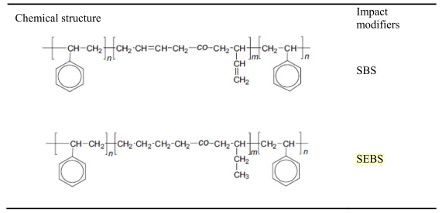
Figure 1: Chemical Structures of SBS and SEBS [7] (Font Cambria Size 10; Centred)
ABS is a common thermoplastic used to make polymeric wood composites, has good physical properties in comparison with other commodity plastics and is cheap in comparison with other engineering plastics [8]. The advantage of ABS is that this material combines the strength and rigidity of the acrylonitrile and styrene polymers with the toughness of the polybutadiene rubber. The most amazing mechanical properties of ABS are resistance and toughness [9]. Acrylonitrile gives chemical resistance and heat stability, butadiene gives toughness and impact strength and the styrene gives rigidity and easiness of process ability, whereas neat ABS as well as other polymers has its limitation in tribology due to high friction coefficient and wear rate [10].
HIPS and ABS are compatible with SEBS, then there is strong probability that SEBS acts as an agent of compatibility between ABS and HIPS. The elastic character of SEBS must bring improved ductile properties to the ABS-HIPS system. One of the first effects that can be observed in the mechanical properties [9]. Mechanical properties of SBS and SEBS are shown in Table 1 below [4].

Table 1: Mechanical Properties of SBS and SEBS [4] (Font Cambria Size 10; Centred)
Properties | P1 | P2
Mechanical properties | SBS | SEBS
Tensile strength (MPa) | 32 | >28
300% Modulus (MPa) | 2.8 | -
% Elongation at break | 880 | >800

From the previous study, a binary blend Acrylonitrile-Butadiene-Styrene and High Impact Polystyrene (ABS-HIPS 50% wt.) was prepared on a twin-screw extruder at 190-210 °C. The different mechanical properties were then analyzed for each experiment conducted. The tonnage capacity of the injection molding machine used is 50 ton (TOYO Ti-Gx50). There are over 200 different parameters that must be established and controlled to achieve proper injection molding of a plastic part. These parameters fall within four major areas: pressure, temperature, time, and distance as shown in Table 2 [7].

Table 2: Melt and mold temperatures for specific materials [7] (Font Cambria Size 10; Centred)
Material | Abbreviation | Melt Temp °c | Mould Temp °c
Acrylonitrile Butadiene | Styrene ABS | 240-280 | 50-80
Low Density Polyethylene | LDPE | 170-240 | 10-40
Polypropylene | PP | 200-270 | 10-40
High Density Polyethylene | HDPE | 180-270 | 10-40
Polystyrene | PS | 180-260 | 10-40

METHODOLOGY

Materials and equipment
A commercial HIPS with MFI of 97 g/ 10 min (200 °C, 5 kg) and specific weight of 1.04 g/cm³ together with ABS with MFI of 95 g/ 10 min (270 °C, 5 kg) and specific weight of 1.03 g/cm³ are used as the polymeric material in present study. TOYO Ti-50GX injection moulding and crusher machine are used for injecting the specimen according to ASTM D638 type 1 as shown in Figure 2. The Toyolac 700 314 Grade ABS and Idemitsu PS HT50 Grade Hips is being used and mixed accordingly. Three parameters are considered in the injection moulding machine are melting temperature, injection pressure and cooling time. INSTRON 3382 tensile test machine was used for performing tensile test.
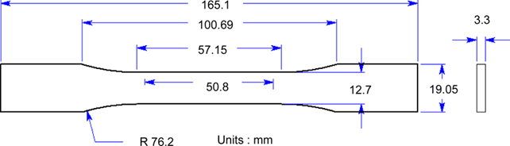

Figure 2: Specification of specimen (ASTM D638 Type I) (Font Cambria Size 10; Centred)

Design of Experiment
A binary blend (50wt%ABS – 50wt%HIPS) was conducted on a conventional twin-screw extrusion machine, at 190 – 195 – 200 – 210 °C extrusion temperatures. Finally, ternary blends were prepared by varying the SEBS content, from 0% to 30 % (wt.%), at the same conditions of ABS-HIPS blends [9]. This research is using 50% recycled HIPS, 45% ABS and 5% SEBS. SEBS is act as coupling agent for these two polymeric materials.
For ABS polymer, the moulding machine should be set up to deliver a melt temperature between 210 to 240°C, with an aim of 230°C for processing the polymer. The optimum temperature profile depends on many variables such as the ratio of machine capacity to shot size, screw design, mould and part design, and cycle time. The mould temperature range recommended for ABS materials is 40 to 60°C. Cooling time is important for part performance and cycle time optimization. Table 3 shows the selected parameters and their levels to conduct the experimentation works. The results obtained as shown in Table 4 were analyzed using a Central Composite Design (CCD) in RSM.

Table 3: Injection Parameter for Experiment (Font Cambria Size 10; Centred)
Moulding Parameter | Level
Melting Temperature (°c) | 200-220
Injection Pressure (MPa) | 90-110
Cooling Time (s) | 16-20

Table 4: Tensile and modulus strength results (Font Cambria Size 10; Centred)
Std | Run | Melt Temperature °C | Injection Pressure (Mpa) | Cooling Time (s) | Tensile  Strength  (MPa) | Modulus Strength  (Mpa)
9 | 1 | 210 | 100 | 20 | 113.98 | 4256.89
10 | 2 | 220 | 100 | 18 | 121.49 | 4241.15
8 | 3 | 210 | 110 | 18 | 114.67 | 4350.02
18 | 4 | 220 | 110 | 16 | 112.62 | 4070.33
7 | 5 | 210 | 100 | 18 | 114.63 | 4113.33
20 | 6 | 220 | 90 | 16 | 116.07 | 4228.16
4 | 7 | 200 | 110 | 16 | 113.65 | 4394.52
11 | 8 | 210 | 100 | 18 | 112.69 | 4348.06
14 | 9 | 210 | 90 | 18 | 111.25 | 4204.82
6 | 10 | 210 | 100 | 18 | 109.29 | 4256.63
1 | 11 | 210 | 100 | 16 | 108.87^{b} | 4266.38
2 | 12 | 220 | 90 | 20 | 115.54 | 4528.78
12 | 13 | 210 | 100 | 18 | 116.33 | 4511.77
15 | 14 | 200 | 100 | 18 | 120.27 | 4465.9
3 | 15 | 210 | 100 | 18 | 116.41 | 4429.28
16 | 16 | 200 | 90 | 16 | 120.89 | 4530.77
13 | 17 | 200 | 110 | 20 | 121.46 | 4653.67
19 | 18 | 220 | 110 | 20 | 113.2 | 4291.1
17 | 19 | 210 | 100 | 18 | 116.39 | 4441.88
5 | 20 | 200 | 90 | 20 | 125.44ª | 4455.65
ª = The highest value of tensile strength
^{b} = The lowest value of tensile strength

A CCD is an experimental design, useful in response surface methodology, for building a second order (quadratic) model for the response variable without needing to use a complete three-level factorial experiment. CCDs are very efficient, providing much information on experiment variable effects and overall experimental error in a minimum number of required runs. CCDs are very flexible [3]. The availability of several varieties of CCDs enables their use under different experimental regions of interest and operability. A Central Composite Design (CCD) is an experimental design, useful in response surface methodology, for building a second order (quadratic) model for the response variable without needing to use a complete three-level factorial experiment.

RESULTS AND DISCUSSION
It can be observed after performing the tensile test, the results were analyzed to study the effect and correlation of recycled HIPS/ABS using CDD method at the different loading ratio. Figure 3 shows the 3D graph representation of recycled HIPS/ABS tensile strength (125.44 MPa) interaction between melting temperature and injection pressure the maximum value of the setting injection moulding parameters. It was found that the tensile strength (125.44 MPa) for recycled HIPS/ABS is maximum when the value of melting temperature (200˚C) and injection pressure (90 MPa) the value of the setting injection moulding parameters. Change cooling time has not significant role in the change of tensile strength but with change in the inejction pressure, there is a significant change in the tensile strength. Tensile strength is minimum when melting temperature and injection pressure is maximum. The melting temperature and injection pressure had more effect on tensile strength than its cooling time. It is observed that melting temperature and injection pressure have positive influence on the tensile strength. This study shows that recycled HIPS/ABS at melting temperature of (210˚C) and injection pressure of (100 MPa) of injection moulding parameters were decrease in response to the cooling time.

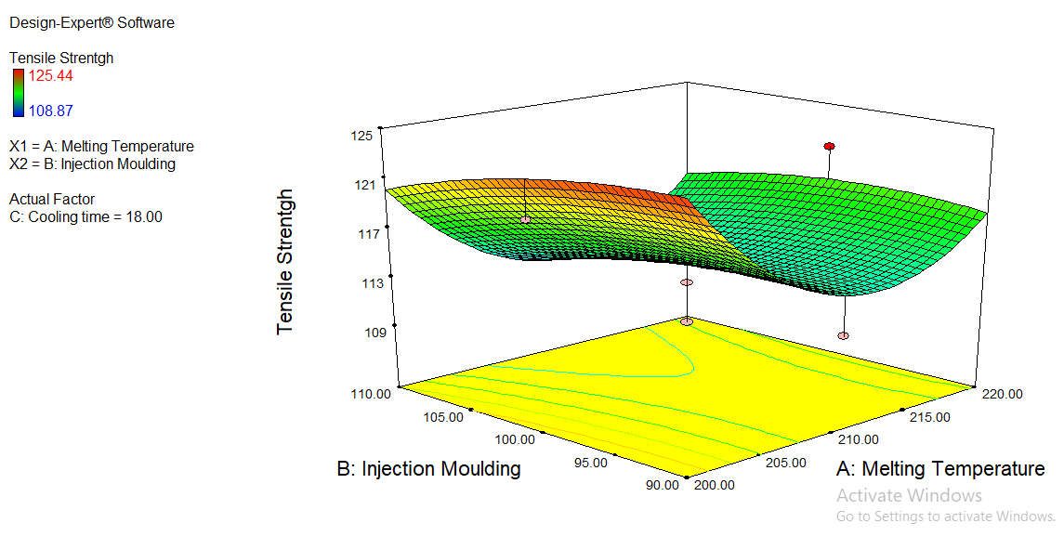
Figure 3: 3D plot effect tensile strength of interaction between melting temperature and injection pressure for recycled HIPS/ABS (Font Cambria Size 10; Centred)

Table 5 has indicated that the analysis of variance (ANOVA) for mechanical properties of recycled HIPS/ABS in term of tensile strength. Statistically, the quadratic model F-value of 3.36 implies the model was significant. The p-value is less than 0.05, indicates that the model is significant. It can be seen that term A, A2 of the model were significant. The p-value for the term A, A2 was significant factor of 0.0353 and 0.0033. For terms A, C and A2 there were no significant factor. The lack of fit F-value of 1.07 implies the lack of fit is that it is not significantly relative to the pure error. From Eqn. (1), the quadratic model of tensile strength for recycled HIPS/ABS in terms of coded factors is given above.

Table 5: ANOVA analysis of tensile strength for recycled HIPS/ABS (Font Cambria Size 10; Centred)
Source | Sum of Squares | df | Mean Square | F Value | p-Value Prob>F
Model | 265.31 | 9 | 29.48 | 3.36 | 0.0364 | significant
A | 51.94 | 1 | 51.94 | 5.91 | 0.0353
B | 18.47 | 1 | 18.47 | 2.1 | 0.1776
C | 30.7 | 1 | 30.7 | 3.5 | 0.0911
A² | 128.63 | 1 | 128.63 | 14.65 | 0.0033
B² | 0.84 | 1 | 0.84 | 2.24 | 0.1566
Residual | 87.82 | 10 | 8.78
Lack of fit | 46.78 | 5 | 9.36 | 1.07 | 0.4446 | not significant
Pure Error | 41.06 | 5 | 8.21
Cor Total | 353.13 | 19

Tensile strength= +114.18-2.28*A-1.36*B+1.75*C=0.68*A*B-1.54+0.55*B*C+6.84*A2-1.08*B2-2.62*c2 … Eqn. (1)

Figure 4 shows that the normal plot of residuals also called the normal probability plot. The normal probability plot is a graphical technique for assessing whether or not a data set is approximately normally distributed. The data are plotted against a theoretical normal distribution in such a way that the points should form an approximate straight line. Departures from this straight line indicate departures from normality. In addition, a straight line can be fitted to the points and added as a reference line. The further the points vary from this line, the greater the indication of departures from normality. Probability plots are used to assess the assumption of a fixed distribution. In particular, most statistical models are of the form of Eqn. (2).

Response = deterministic + random … Eqn. (2)

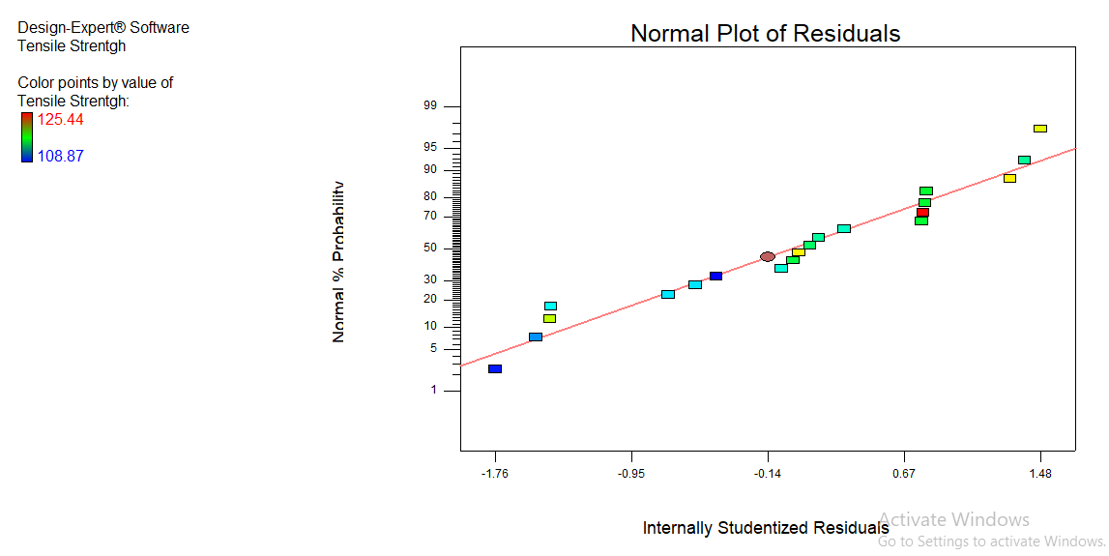
Figure 4: Normal plot of residuals (Font Cambria Size 10; Centred)

Where the deterministic part is the fit and the random part is error. This error component in most common statistical models is specifically assumed to be normally distributed with fixed location and scale. This is the most frequent application of normal probability plots. This model is fitted and a normal probability plot is generated for the residuals from the fitted model.

CONCLUSIONS
From the experiment, it can conclude that the research works confirmed that, the optimum formulation was achieved with composition of 50% recycled HIPS,45% ABS, and 5% SEBS-g-MA to produced recycled HIPS/ABS blends. The temperature of 200˚C (low) was found to give the highest tensile strength (125.44 MPa) for recycled HIPS/ABS. Meanwhile the medium melting temperature (210˚C) of recycled HIPS/ABS resulted the lowest tensile strength (108.87 MPa).
It was found that the cooling time has no significant effect on mechanical properties. It can be observed that the melting temperature is the most significant factor affecting the tensile strength. A part of that, recycled HIPS and ABS are compatible with SEBS and establishing good bonding between these two polymeric materials which resulted the optimum tensile strength is obtained.
For this study, the experimental works are designed based on the Design of Experiment (DOE) together with the variable and the parameter selected which resulting the major and minor error such as random error can be minimize and avoided. Hence, the data and result that obtained from experiment is reliable and trusted and can be used by recycling the plastic for downgrade applications. Also, the recycled material can reduce the cost by reusing it again and again.
Author Contribution
M. Mohd: Conceptualization, methodology, investigation, visualisation, writing and editing. S. N. Diana: Investigation, supervision, writing, and editing. Author: Methodology, writing and editing.
Conflict of Interest
The authors declare that they have no known competing financial interests or personal relationships that could have appeared to influence the work reported in this paper.

Acknowledgements
The authors acknowledge the financial support of the Ministry of Higher Education (MOHE) Malaysia for the fund under Fundamental Research Grant Scheme FRGS1/2018/STG07/TATI/01/1 and UC TATI for the granted internal UC TATI grant (GPJP 1/9001- 2010) which makes this work possible.

REFERENCES Vancouvers Style (Font Cambria size 10), minimum 30

[1] Alias M, Ainul Ayunie R, Nor Bahiyah B. Effect of Injection Molding Parameters on Recycled ABS (r-ABS) Mechanical Properties. Indian J Sci Technol. 2016; Vol 9(9).
[2] Balani K. Physical and Mechanical properties of Polymers. In Biosurfaces: A Materials Science and Engineering Perspective. John Wiley & Sons, Inc; 2015; 329–344.
[3] Carley, KM, Kamneva, NY, Reminga, J. Response Surface Methodology 1 CASOS Technical Report School of Computer Science; 2004 October.
[4] Direksilp C, Threepopnatkul, P. Performance improvement of PS From Expanded Polystyrene off-grade. Energy Procedia, 2014; 56(C), 135–141.
[5] Focke, WW, Joseph, S, Grimbeek, J, Summers, GJ, Kretzschmar, B. Mechanical properties of ternary blends of ABS + HIPS + PETG. Polym Plast Technol Eng. 2009; 48(8), 814–820.
[6] Goutham R, Veena TR, Babagowda, Prasad KRS. Study on mechanical properties of recycled Acrylonitrile Butadiene Styrene (ABS) Blended With Virgin Acrylonitrile Butadiene Styrene (ABS) Using Taguchi Method. Materials Today: Proceedings,2018; 5(11), 24836–24845.
[7] Koffi A, Koffi D, Toubal L. Injection Molding Parameters Influence on PE Composites Parts. Int J Eng Res Dev. 2016; 12(10), 29–39.
[8] Mendes Campolina J, São Leandro Sigrist C, Faulstich de Paiva JM, Oliveira Nunes A, da Silva Moris VA (2017). A study on the environmental aspects of WEEE plastic recycling in a Brazilian company. Int J LCA. 2017 March; 1–12.
[9] Peydro Rasero MA, Juarez D, Sanchez Caballero S, Parres F. Study of the Mechanical Properties of Acrylonitrile Butadiene Styrene – High Impact Polystyrene Blends with Styrene. Annals of the Oradea University, Fascicle of Management and Technological Engineering, 2013; (1), 269–272.
[10] Sudeepan J. Kumar K, Barman TK, Sahoo P. Study of Friction and Wear of ABS/ZnO Polymer Composite Using Taguchi Technique. Procedia Mat Sci 6(Icmpc). 2014; 391–400.

